An ISO 9001:2015 Certified

**RAPTI ENGINEERING COLLEGE**

(Affiliated to Pokhara University)

**Ghorahi Sub-Metropolitan-16 Saniambapur, Sarra Dang**

PROJECT PROPOSAL

ON

**“VerifiAI : Unified AI-Generated Content Detector”**



To the Project Proposal Evaluation Band

Submitted To:

Department of Dcom

Rapti Engineering College

Submitted By:

Santosh Poudel

Yamuna oil

Devraj Kunwar

Rapti Engineering College

Ghorahi Dang.

Subject: Submission of Proposal on “**VerifiAI , Unified AI-Generated Content Detector**”

Dear Sir,

We hope this message finds you well. We, the undersigned students of the DCom program at Rapti Engineering College, are writing to seek your approval and support for our proposed final year project: the development of a **multi-modal AI-generated content detection web application**.

Our team comprises three enthusiastic students who are eager to apply our technical knowledge and creativity to a real-world project. With the rapid rise of AI-generated content across platforms, we aim to build a web application that can detect whether text, images, videos, or files are created by artificial intelligence or by humans.

This project will not only help us enhance our skills in frontend and backend web development, API integration, and database management, but will also strengthen our abilities in teamwork, communication, and project planning.

We believe this solution has real-world relevance and the potential to benefit both educational and professional environments by promoting content authenticity.

We kindly request a meeting at your earliest convenience to present our proposal in more detail and discuss your valuable feedback. Your mentorship and guidance would be instrumental in the successful execution of this project.

Thank you for your time and consideration. We look forward to your support and the opportunity to work under your supervision.

Sincerely,

**Student of Dcom**

**Team: ChainLink**

**1.Santosh poudel**

**Role**: Responsible for the complete design, development, integration, testing, deployment, and presentation of a full-stack AI content detection web app.

**2.Deb raj kunwar**

**Role** : supporter

**3.Yamuna oli**

**Role** : supporter

**TABLE OF CONTENTS:**

1. **Introduction to the project………………………………1**

1.1 Existing System Overview …………………………..1

1.2 Proposed System Definition ……………..………….2

1. **Features of the Project …………………………………..3**
2. **Objectives of the Project ………………………………..4**
3. **Scope of the Project……………………………………….5**
4. **Methodology ……………………………………………..6**
5. **Tools Used ………………………………………………..7**

6.1 Back End **………………………………………………7**

* 1. Front End  **………………………………………………7**

1. **ER-Diagram……………………………………………….8**
2. **Gantt Chart………………………………………..………9**

**9. Conclusions………………………………………….…..…10**

**10. References…………………………………………..…….11**

1. **Introduction to the Project**

**“ VerifiAI ”** is an innovative web application designed to detect whether digital content—such as text, images, videos, or files—has been generated by artificial intelligence. As AI technologies advance rapidly, distinguishing between genuine human-created content and AI-generated material has become increasingly challenging. This poses serious risks, including the spread of misinformation, deepfake scams, and fraudulent activities that can deceive users.

Our project aims to develop a comprehensive platform that empowers users to verify the authenticity of digital content and protect themselves from potential scams and misinformation. By integrating advanced AI detection tools, VerifiAI will analyze multiple types of content and provide clear, reliable results about their origin.

This system is crucial in today’s digital landscape, where AI-generated content is widespread and can easily be mistaken for genuine media. VerifiAI will help individuals, businesses, educators, and institutions maintain trust and transparency online.

As students of **Rapti Engineering College**, we have chosen to create VerifiAI to contribute to safer digital communication and promote awareness about AI-generated media. Our project will enhance digital security by enabling users to identify and respond to AI-generated content effectively.

Through this endeavor, we aim to develop strong technical skills in web development, AI integration, and user interface design, while providing a practical tool that addresses a growing real-world problem.

**1.1 Existing System Overview:**

Current solutions for detecting AI-generated content often suffer from several limitations. Many existing platforms provide separate tools for detecting AI text, images, or videos, but lack an integrated, user-friendly interface that supports multiple content types in one place. Additionally, these systems may have outdated or complex user interfaces that are not intuitive for all users, especially those without technical expertise.

Traditional detection tools often require users to upload content and wait for slow, server-heavy processing, which can result in delays and a fragmented user experience. This lack of interactivity and real-time feedback can make it difficult for users to quickly verify the authenticity of content.

Furthermore, most existing solutions focus on only one type of media, forcing users to use multiple platforms to analyze text, images, and videos separately. This fragmented approach reduces efficiency and accessibility for users looking for a comprehensive AI content detection tool.

Our project aims to overcome these limitations by providing a seamless, integrated, and responsive web application that supports real-time detection of AI-generated text, images, videos, and files. By focusing on ease of use and performance, we strive to deliver a tool that protects users from scams and misinformation in a single, accessible platform.

**1.2 Proposed system:**

The proposed system, **“VerifiAI”**, will be developed using **Next.js** for the frontend, **Node.js** for the backend, and **MongoDB** as the database. This application aims to provide a modern, efficient, and user-friendly platform for detecting AI-generated content across multiple formats including text, images, videos, and files.

Key advantages of this system over existing solutions include:

* **Comprehensive Detection:** Integrates AI detection for various content types in a single platform, reducing the need for multiple tools.
* **Time and Cost Efficiency:** Automates the verification process, enabling faster content analysis and reducing manual efforts in identifying AI-generated media.
* **User-Friendly Interface:** Provides a seamless, intuitive experience with real-time feedback and minimal page reloads, accessible to both technical and non-technical users.
* **Enhanced Security:** Helps protect users from deepfake scams, misinformation, and fraudulent content by reliably identifying AI-generated materials.
* **Scalable and Flexible:** Supports expanding detection capabilities and user roles, accommodating diverse user needs and future enhancements.
* **Global Accessibility:** Offers a web-based platform accessible from anywhere, promoting awareness and trust in digital content worldwide.

By developing this system, we aim to empower users to confidently evaluate digital content authenticity and reduce the risks associated with synthetic media.

**2.Features of the Project:**

In our project, **VerifiAI**, we incorporate a wide range of key features essential for effective detection and management of AI-generated digital content. The system is designed to be user-friendly and secure, catering to both regular users and administrators. The main features include:

**AI Content Detection:**

* Detects AI-generated text, images, videos, and files using advanced AI models and APIs.
* Provides clear, easy-to-understand results to help users identify synthetic content.

**User Management:**

* Secure user authentication and role-based access control to protect sensitive features and data.
* Supports different user roles such as general users and administrators.

**Administrative Control:**

* Admin dashboard to manage detection settings, view detailed reports, and oversee user activity.
* Controls to update detection models and configure system parameters.

**Real-Time Analysis:**

* Fast, responsive content scanning with minimal delays to provide instant feedback.
* Supports bulk uploads and various file formats.

**User-Friendly Interface:**

* Intuitive and responsive design to ensure ease of use for both technical and non-technical users.
* Clear visual indicators and detailed explanations of detection results.

**Security and Privacy:**

* Ensures secure handling of user data and uploaded content, respecting privacy and compliance standards.

**Global Accessibility:**

* Web-based platform accessible from any device or location, enabling users worldwide to verify content authenticity.

**3.Objective of the Project:**

The main objectives of the **VerifiAI** project are:

* To develop an efficient platform that detects AI-generated content across multiple formats, including text, images, videos, and files.
* To enable users to upload and analyze digital content easily through a secure and intuitive web interface.
* To provide accurate detection results that help users distinguish between human-created and AI-generated content.
* To enforce data security and privacy, ensuring that only authenticated and authorized users can access sensitive information.
* To design a user-friendly and responsive platform accessible on various devices.
* To integrate advanced AI detection models and APIs for reliable and real-time analysis.
* To offer administrative controls for monitoring system performance, managing users, and updating detection tools.
* To contribute to combating misinformation and protecting users from AI-driven scams and deepfake.

**4.Scope of the Project:**

The main aim of the **VerifiAI** project is to develop a comprehensive web application that detects AI-generated content across multiple formats, including text, images, videos, and files. This platform targets individuals, educational institutions, businesses, and organizations that need to verify the authenticity of digital content and protect themselves from AI-driven scams, misinformation, and deepfakes.

Users will be able to upload or input various types of digital content from any device with internet access and receive fast, reliable detection results. The system focuses on providing an intuitive and responsive user experience that is accessible to both technical and non-technical users.

VerifiAI prioritizes security by enforcing role-based access control and safeguarding sensitive data to ensure privacy and authorized use. By integrating cutting-edge AI detection models with scalable backend architecture and a dynamic frontend interface built using Next.js, Node.js, and MongoDB, the platform delivers efficient processing and reliable detection results.

The project also scopes to support ongoing updates of detection algorithms, detailed reporting, and administrative oversight to maintain accuracy and user trust. Overall, VerifiAI aims to contribute to a safer digital environment by empowering users to identify AI-generated content easily and effectively.

**5. Methodology :**

For the development of this project, our team has chosen to follow the **Spiral Model**. This iterative approach combines elements of both design and prototyping in stages, allowing us to manage risks effectively and accommodate changes throughout the development process.

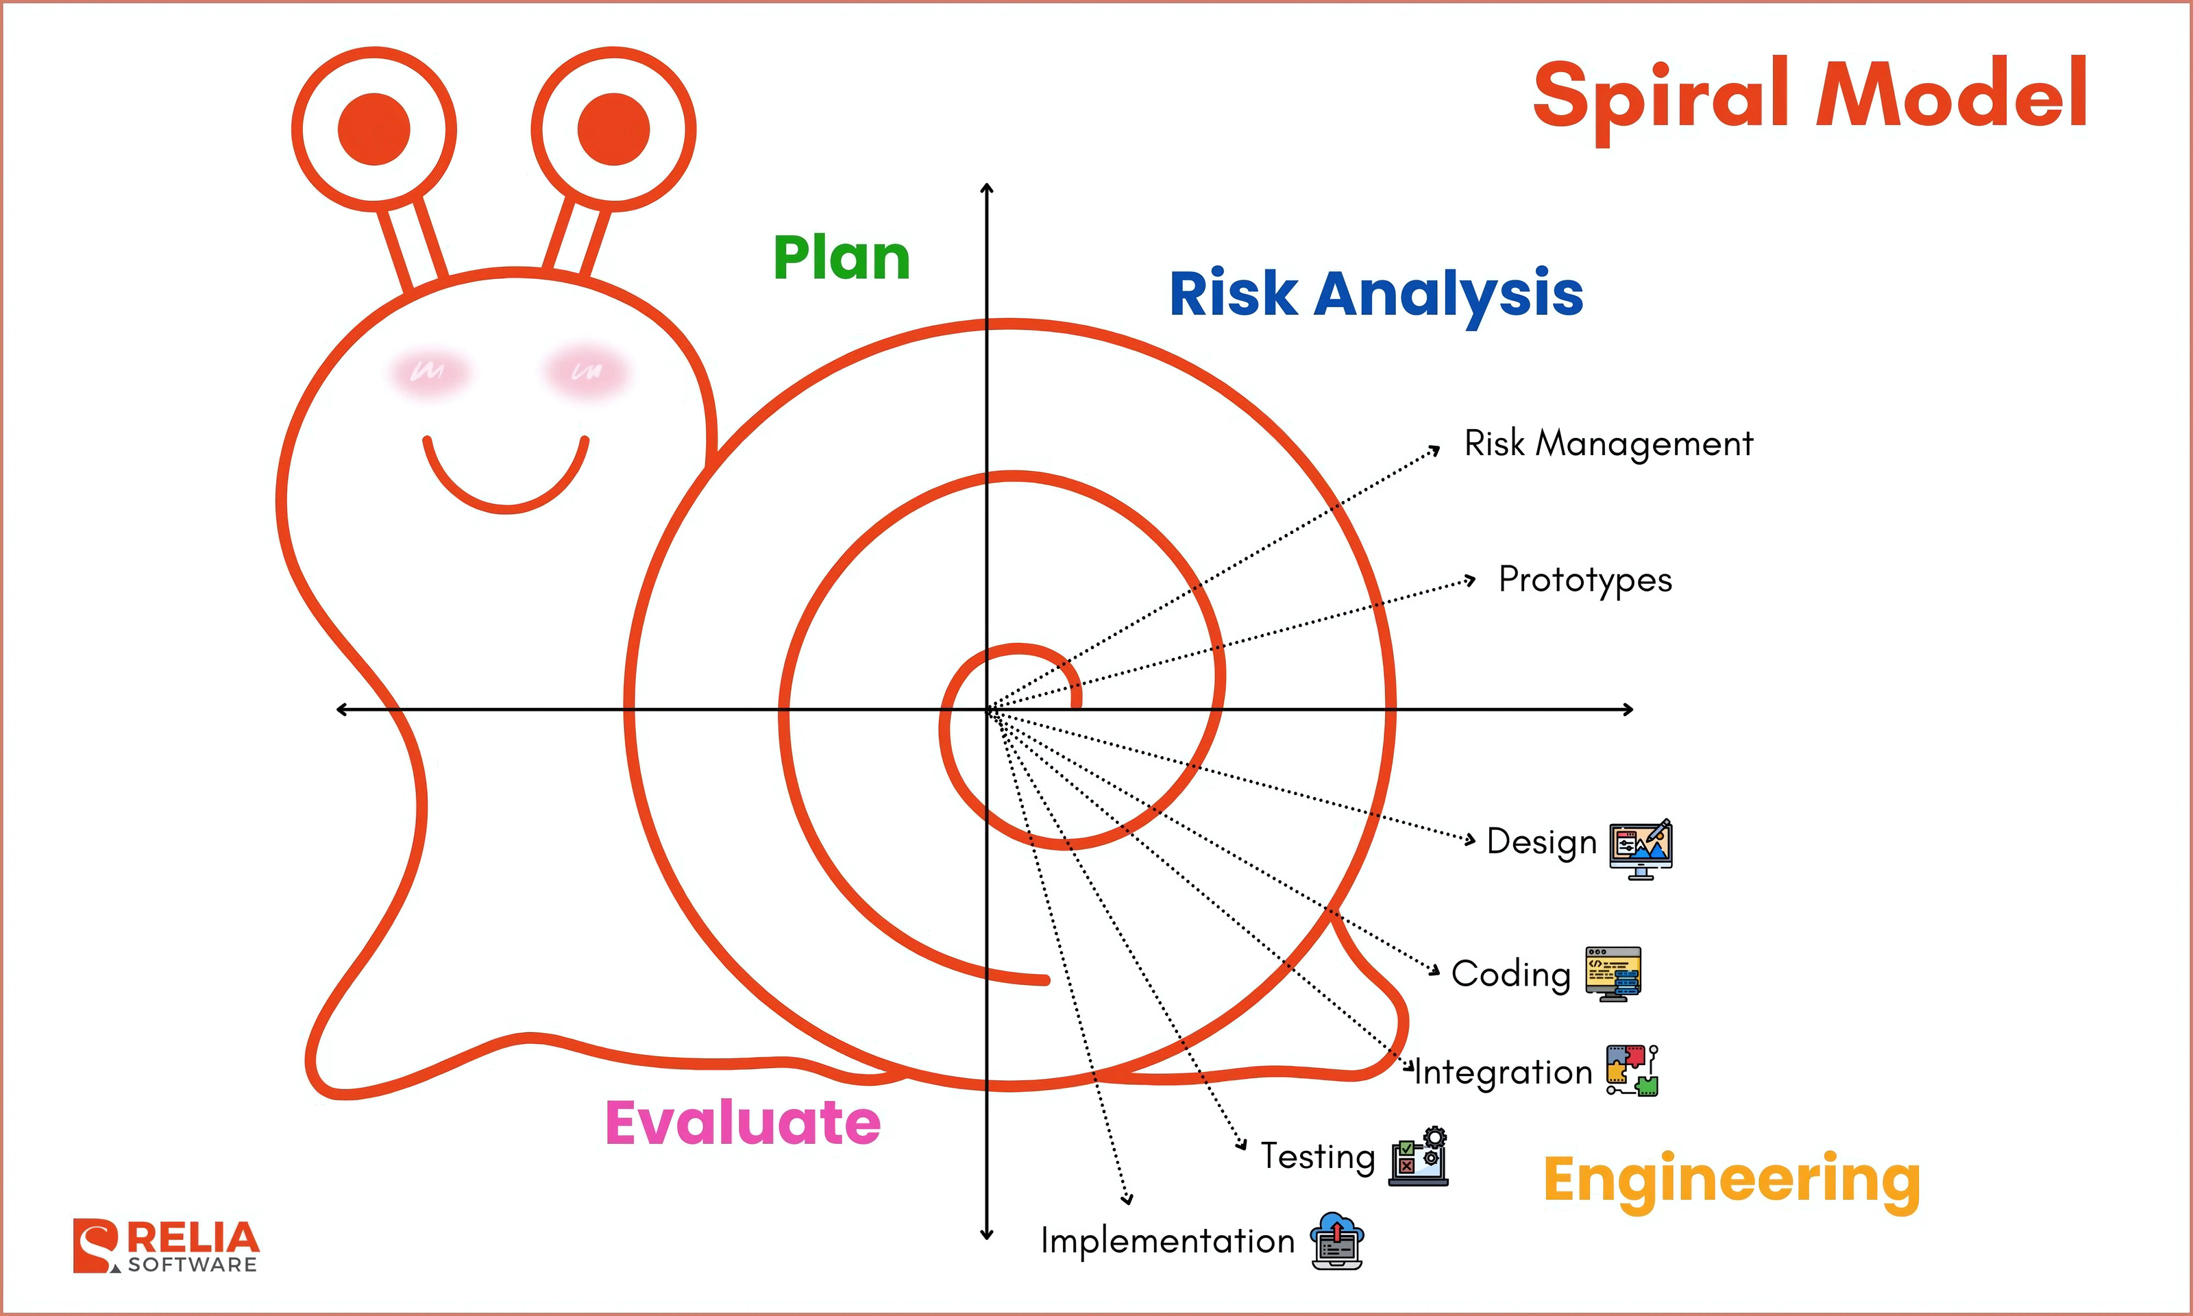

**6. TOOLS USED**

**6.1 Frontend Design:**

For the frontend, we have chosen **Next.js** with **TypeScript** and **Tailwind CSS** to build a modern, fast, and responsive user interface.

* **Next.js** is a React framework that supports server-side rendering and static site generation, improving performance and SEO.
* **TypeScript** adds strong typing to JavaScript, enhancing code quality and maintainability.
* **Tailwind CSS** is a utility-first CSS framework that allows rapid and consistent styling with minimal custom CSS.

6.2 Backend Design

Our backend is developed using **Python**, providing powerful capabilities for AI integration and API management.

* Python allows seamless integration with AI services and machine learning models for content detection.
* We use **Firebase** for authentication, real-time database, and secure cloud storage solutions, which simplifies user management and data handling.
* AI detection APIs such as **OpenRouter** and **Hugging Face** are integrated to perform AI-generated content analysis across text, images, and videos.

This technology stack ensures a scalable, efficient, and user-friendly web application capable of real-time AI content verification.

**ER - Diagram:**

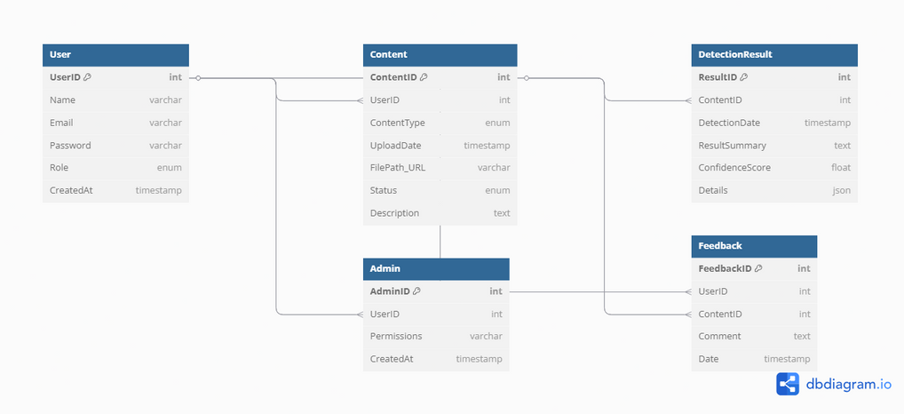

**8.Gantt Chart :**

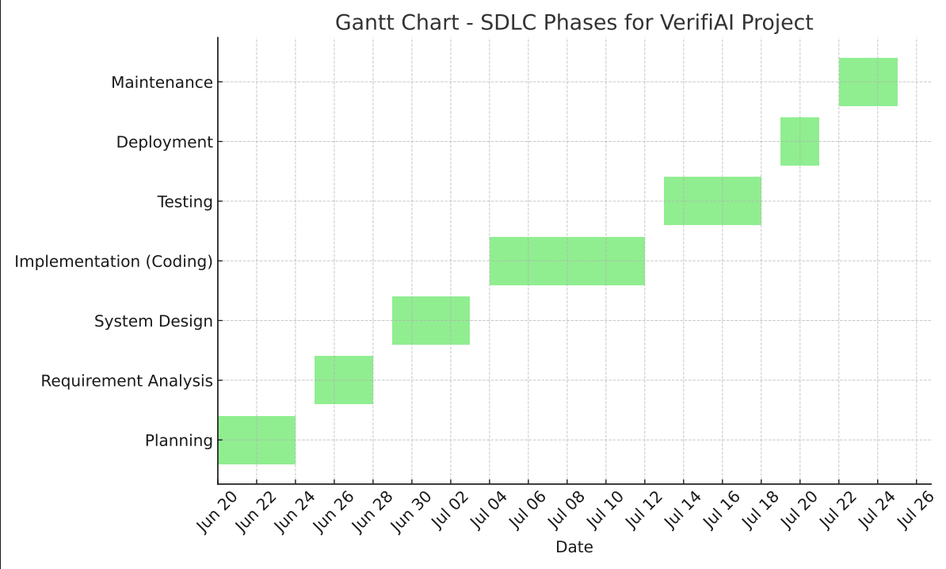

9.**Conclusion:**

The VerifiAI system is developed as a modern solution to address the growing challenge of identifying AI-generated digital content. As artificial intelligence becomes more advanced, the risk of misuse—such as deepfakes, fake news, and synthetic media—continues to rise. This project offers a secure, automated, and user-friendly platform that allows users to verify the authenticity of content across various formats including text, images, videos, and files.

By integrating AI detection models with robust frontend and backend technologies, VerifiAI simplifies the process of content verification and empowers users to make informed decisions online. It reduces the need for manual inspection, enhances digital trust, and contributes to the broader goal of combating misinformation.

We believe this project reflects the effective use of modern web technologies and machine learning integration to build a tool that is both practical and impactful in today’s digital landscape. VerifiAI not only strengthens our technical foundation but also provides a real-world solution to a pressing digital problem

**10. References:**

* https://www.google.com
* https://chat.openai.com
* https://canva.com
* https://dbdiagram.io/